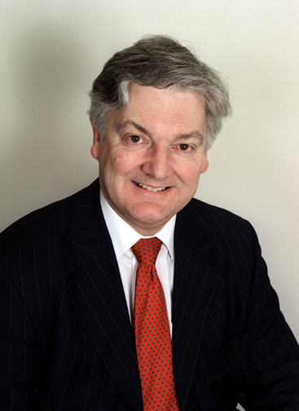

The leader of the United Future New Zealand Party, Hon. Peter Dunne, wishes all the readers of Capital Chinese News a very happy and prosperous New Year.

United Future’s MP’s are committed in this Year of the Goat to maintaining and improving the lot of new New Zealanders and visitors to our country and to promoting the health, wealth and stability of New Zealand families.

It is our long-term goal to become a major political force in New Zealand representing middle, hard-working New Zealanders who help to make this country the wonderful place it is to live in.

